**SELF SWITCHING POWER SUPPLY**

**ABSTRACT:**

Embedded system requires a regulated power supply. This power supply circuit gives a variable regulated supply and switches off in no load condition.

Through an arrangement of voltage regulator 7805 and a potentiometer the output voltage is varied from 3.7V to 8.7V. Another feature of this power supply is, when no load is there it automatically switches off. It is achieved through an arrangement of transistors and relay.

**BLOCK DIAGRAM**

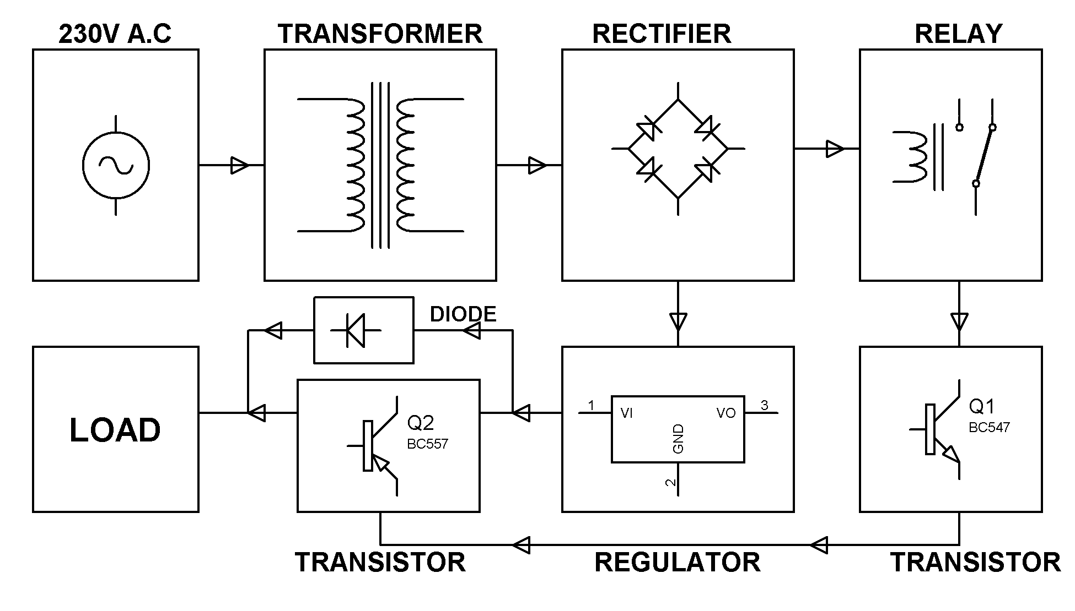

**HARDWARE REQUIREMENT:**

1. TRANSFORMER.
2. RECTIFIER.
3. FILTER
4. REGULATOR.
5. RELAY.
6. TRANSISTOR (BC 547 & BC 557).
7. RESISTOR.
8. CAPACITOR.
9. 1N4007.